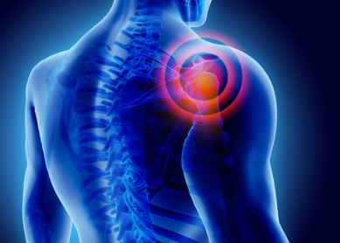
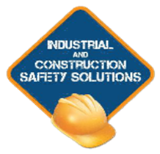
Egonomics Awareness Training
Program Overview:
Ergonomics is the study of people at work.
The workplace needs to design tasks, workspaces, controls, displays, tools, lighting, and equipment to fit the employee.
Ergonomics in the workplace plays a very important role in the reduction of worker pain and suffering.
The objective of this training is to provide people with the knowledge, and information to accomplish their job tasks safely to prevent a musculoskeletal injury.

Training Content:
- Injury statistics involving Musculoskeletal Disorders
- The Musculoskeletal System
- Ontario Legislation
- What is Ergonomics?
- Identifying Ergonomic Risks
- Work Related Musculoskeletal Disorders
- Recognizing Ergonomic Issues
- Injury Risk Factors
- Some Methods of Controlling Ergonomic Risks
- Video – Ministry of Labour Material Handling
- Knowledge Check (Quiz) at the end

Course Duration:
- This is an on-line e-learning course.
All you need is a computer, access to the Internet - and you are ready to go!
- The course allows you – the learner to learn at your own pace and convenience.

info@safety-solutions.ca 613-498-2722 www.safety-solutions.ca
Legal Disclaimer
It is the employer’s responsibility to ensure that each of their employees is properly trained. This program provides training of a general nature and may not include the hazards that are unique to your workplace. The intent of this training program is to outline expected industry standards. Employers must always ensure that their workers are properly trained according to the hazards and regulations specific to their workplace and job tasks. Industrial and Construction Safety Solutions has made every attempt to ensure the accuracy and reliability of the training material that has been provided in this training program.

