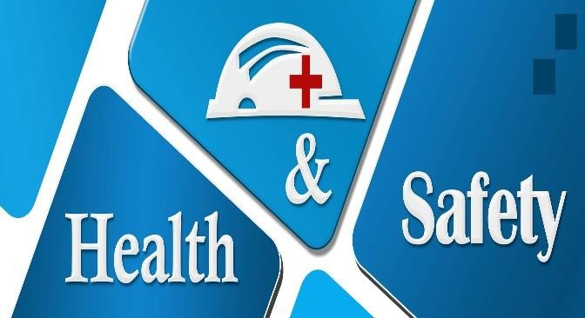

Health & Safety at Work for Employees

Program Overview:
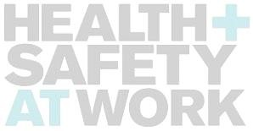
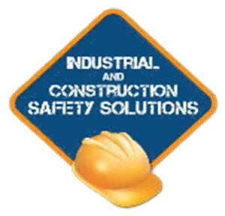
The Occupational health and safety awareness training provides a basic understanding of the Occupational Health and Safety Act (OHSA), and does not replace any sector specific, hazard specific, or competency specific training. This training introduces workers to the Occupational Health and Safety Act. It focuses on the health and safety rights and responsibilities of workers, supervisors and employers. It also serves as a general introduction to workplace health and safety.

Training Content:
- OHSA
- Duties of the Employer, Supervisor and Worker
- Rights of the Worker
- Hazards
- Hazard prevention and awareness
- PPE
- JHSC & Safety representatives
- Information and Recourses

Course Duration:
- Four (4) Hours dependent upon number of participants

info@safety-solutions.ca 613-498-2722 www.safety-solutions.ca

February 1, 2019 Revision 01

