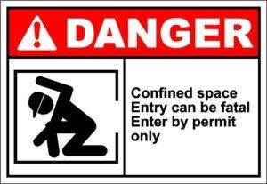
Confined Space Awareness

Program Overview:
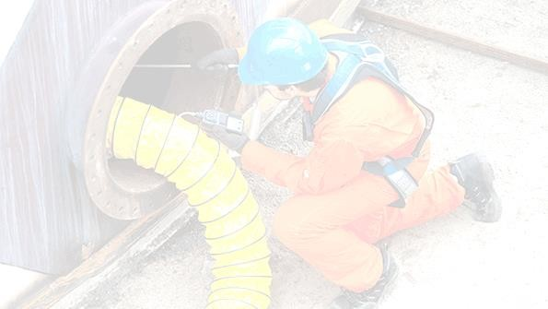
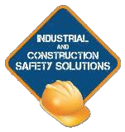
- This program is based on Confined Space Regulation 629/05 and the CSA Z1006-16 Standard. The program teaches overall confined space awareness, existing and potential confined space hazards, methods to control and eliminate hazards, training requirements, attendant and entrant as well as workplace responsibilities, the permit, entry planning, authorization and emergency and rescue procedures.

Training Content:
  - Confined Space Recognition
  - OSHA and Reg. 629/05, CSA Z1006 -16
  - Hazard Assessment
  - Confined Space Entry Plan
  - Testing & Monitoring
  - Entry Permits
  - Attendant and Entrant
  - Communication
  - Isolation Procedure & Techniques
  - Documented Work Procedures
  - Training Requirements
  - Rescue Requirements

Course Duration:
  - Eight (8) Hours dependent upon number of participants
NOTE: Confined Space Practical Training is an additional ½-day of training, based on applications and scenarios using the participants’ workplace rescue equipment.
info@safety-solutions.ca 613-498-2722 www.safety-solutions.ca

February 1, 2019 Revision 01

